Feedback Session 1

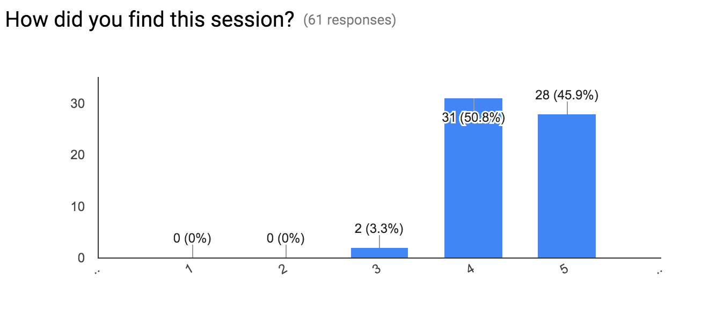

1 thing we could improve for the next session? (33 responses)

* It took a long time to say relatively little. Would be better to assume some programming knowledge (e.g. no need to explain nan values).
* Free food and beverage...?
* People support and help
* Specific instructions for technical details
* Easy practice exercises? Just to get more familiar with the commands
* some more tutors to help
* It was quite good.But a few things were unexplained in the slides , a little more detail would be appreciated.
* none
* More tutors perhaps
* Perhaps provide us with some exercises to do at home to work through things presented
* Smaller sessions would be more useful
* Resend the email with all the relevant links for the resources we need, like the links to the code, and the slides. Thank you!! :)
* Less time spent on installing stuff
* Write clearer bit.ly links.
* Shorter, keep a git/drive with all the docs on or email them, bit.ly links on a board doesn't work when everyone has a laptop. Presenter was good but you need more helpers, the lack of them slowed the presentation down. But overall good.
* Installing readr should have been a prerequisite. It's understandable that getting everyone's computers working takes time though.
* more examples
* more examples
* Make it clear when the next session is
* It's so cold in here.
* Provide the session slides in powerpoint format rather than in Google Docs format (it makes it easier to follow).
* Slightly more interactivity
* No, the format is good
* Nothing! - So good!
* Perhaps more time to work on the assignments/examples, however, the instructions were very clear and the information was presented in an easy to follow way - perfect for beginners. An excellent introductory session overall!
* Preferably shorter periods, more sessions with slower pace
* A more conducive venue, like a classroom, would facilitate easier question answering
* More programming
* You're Acing it; thank you so much!
* It couldn't be more inform-R-tive!
* If the session could be recorded, it'd be great!
* not much, it was great!
* Food maybe?